**Frequently Asked Questions**

**What information is provided in this Freight Map Application?**

The purpose of this freight map application is to provide detailed truck performance measure and truck intermodal information to WSDOT users (planners, traffic, design, regions, and communicators). The first phase of this application has been completed and integrates following information:

1. Truck freight performance measures based on truck GPS data, including truck average speeds, and roadway reliability.
2. Freight information obtained from other sources, including AADT, WSDOT Freight and Goods Transportation System, and Truck Percentage.
3. General information including state route and functional class features, political boundaries such as city limits, interchange drawings, region boundaries, congressional districts, county boundaries, legislative districts, MPO, RTPO, township and tribal areas.

Users can turn on or turn off different data layers by clicking the checkbox next to the layer name. To get more detailed information for each data layer, users can click on interested roadway segment or area to get a pop-up window. Users can also access the metadata document by clicking the layer option button next to layer’s name.

**What is the data source for the Freight data layers?**

Except the AADT Truck percentage, WSDOT Freight and Goods, and AADT layers, all the rest data layers under “Freight” Tab were developed based on the truck GPS data.

The truck GPS data was collected for one year (September 2010 to September 2011) from about 6,000 GPS-equipped trucks per day traveling on roads throughout Washington State. The commercial in-vehicle GPS devices report, via cellular technology, both at preset intervals (every 10 to 15 minutes) and when the trucks stop. The resulting GPS data set includes reads for individual truck’s longitude and latitude, the truck’s ID (scrambled for privacy), spot (instantaneous) speeds, and a date and time stamp.

**Why does the segment size vary and how is the roadway network partitioned into individual segments?**

Utilizing geographical information system (GIS) techniques, the state’s roadway network was partitioned into individual segments at following locations: access ramps, changes in posted speed limit, county boundaries, urban/rural area boundaries, and signalized intersection. Then the truck GPS data was assigned to these segments to evaluate the roadway performance.

**Is the freight performance measure data available for all the highway segments within Washington State?**

The performance analysis was only conducted for the segments with enough GPS truck data reads for a valid analysis—a minimum of a 200 trucks per segment per year. 200 were used as the minimum data threshold to ensure that the sample size is large enough to be representative of the roadway condition.

**What is the definition of travel reliability?**

The reliability refers to whether the travel conditions during a given time period (in the central Puget Sound region) or a given day (in the non-Puget Sound areas of the state) are reliable, given the speed distribution and a statistical fitting process. Generally speaking, if the speed distribution has two speed “humps” and is bimodal (such as in Figure 1a), then the travel condition is considered unreliable. Otherwise, the travel condition is unimodal and is considered reliable with one average speed (as in Figure 1b).

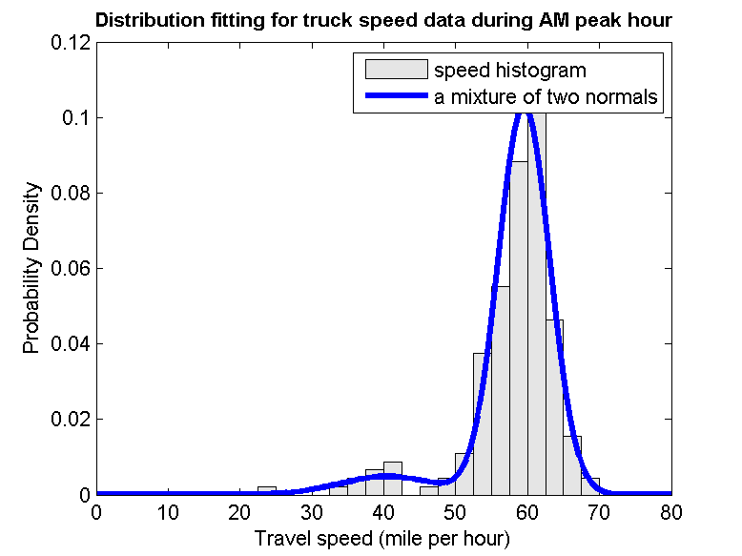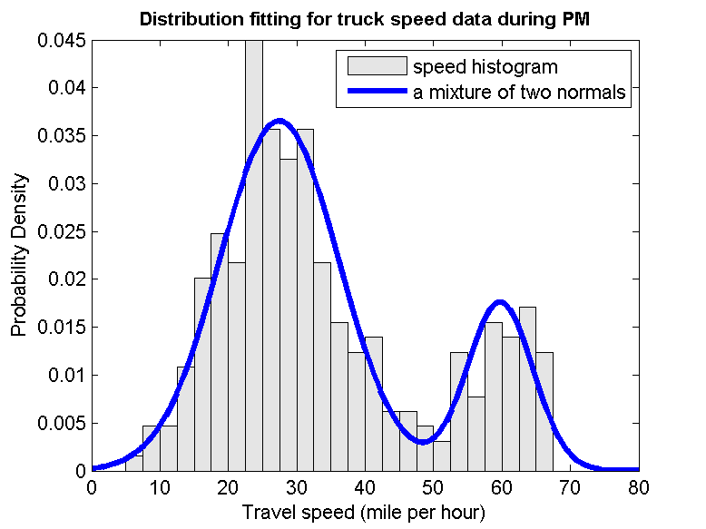

**Figure 1: Speed Distribution: (a) speed distribution with a bimodal feature (b) speed distribution with a unimodal feature.**

**What is the definition of severe speed threshold?**

Sever Speed Threshold refers to the percentage of truck spot speeds falling below 60 percent of the posted speed limit. 60 percent of posted speed was selected as the threshold because it is used in WSDOT congestion report as the speed threshold for evaluating whether the freeways are experiencing severe congestion. 1-year aggregate data was used to evaluate the reliability measure for any roadway segment.

**What is the definition of AM, Midday, and PM time periods?**

AM time period is 6 am – 9 am; Midday time period is 9 am – 3 pm; and PM time period is 3 pm – 7 pm.

**Why are the freight layers for speed, reliability and bottlenecks divided into Puget Sound sublayer and statewide sublayer?**

The evaluation process separates Washington State into Puget Sound area and the rest of the state (referred as statewide). That is because the methodology adopted for Puget Sound and statewide is different and therefore the performance measures for two parts are not comparable. For Puget Sound area, the GPS data was divided into three time periods (AM, Midday, and PM) for performance analysis, while for statewide, entire daytime data without differentiating time periods was used for analysis. Therefore the reliability measures for Puget Sound and for statewide are not comparable.

**What is the WSDOT Freight and Transportation System?**

This layer displays the classification of state highways, county roads, and city streets according to the average annual gross tonnage they carry in 2011. The roadways are classified into five different categories:

* T-1 (more than 10 million tons per year)
* T-2 (4 million to 10 million tons per year)
* T-3 (300,000 to 4 million tons per year)
* T-4 (100,000 to 300,000 tons per year)
* T-5 (at least 20,000 tons in 60 days and less than 100,000 tons per year)

Such classification is the same as FGTS classification system adopted by FMSIB.

**What information will be provided in next phase?**

The next phase of Freight map will provide following additional data layers:

* Intermodal facilities;
* Manufacturing and industrial centers;
* Port locations;
* Safety rest areas with truck parking;
* Bridges;
* Weigh stations;
* Truck-related accident locations.

**Is the sample of probe vehicles representative of the traffic flow? Could probe vehicle data provide accurate speed and reliability measurement?**

The use of probe vehicles is a common technique among public agencies for monitoring traffic conditions, identifying bottlenecks, and for providing near real-time traveler information. One reason for the prevalence of probe vehicle programs is that they provide usable quantitative information about roadway conditions while also being cost effective and, with the advent of GPS technology, easy to implement. The USDOT travel time data collection handbook, notes GPS probe vehicles techniques are low cost and provide a good level of accuracy without a large sample size (FHWA 1998, 2-19).

A number of North American agencies that routinely use of GPS equipped probes to collect performance data can be found. In partnership with the American Transportation Research Institute (ATRI), FHWA launched the Freight Performance Measurement program in 2002 and has been using national truck GPS data to measure truck travel speed and reliability along interstate highways, and to quantify major chokepoints along highways. The Ontario Ministry of Transportation has an ongoing GPS probe road performance data collection program used to improve the understanding of freight demand and road performance to make informed investment decisions. On the east coast, the I-95 Corridor Coalition started the I-95 Vehicle Probe Project in 2008 to develop and maintain a corridor wide traffic monitoring system to deliver travel times and speeds on freeways and arterials (I-95 2011, 2012). The data quality is validated by comparing private sector INRIX GPS probe data to ground truth data from Bluetooth devices.

There are a number of research papers investigating the minimum sample size of GPS probe vehicles needed to achieve the desired accuracy of traffic state estimation. Those papers are typically statically based and technical. Example studies can be found in the references below. These studies indicate that a small percentage of probe vehicles can provide a good representation of roadway traffic condition. For example, it was concluded by Cheu (2002) that for an absolute error in estimating average arterial link speed to be less than 5 km/hr at least 95% of the time, the network needs to have 4% to 5% of active probe vehicles, or at least ten probe vehicles must pass through a link within the sampling periods. An older WSDOT funded study (Hallenbeck et al 1992) found that 45 AVI equipped probe vehicles with a 30 minute headway could yield useful roadway performance information.

Recognizing that probe trucks could provide information about the performance of the freight network, WSDOT initiated the state truck performance measure program in 2007. This effort systematically analyzes the entire truck freight network and quantifies delay at truck freight bottlenecks. In the current phase of the program, the team receives daily GPS data from a large GPS vendor for more than 6,000 trucks traveling on roads throughout Washington state. The resulting GPS data set includes reads for truck’s location, spot speed, timestamp and other engine related information at preset intervals (every 10 to 15 minutes). Initial research was conducted to verify the accuracy of GPS reported spot speed by comparing these speed with dual-loop detector speed measurement along SR 167 (Zhao et al. 2011). The researchers concluded that speed estimation based on GPS spot speed collected over long periods can capture typical travel conditions and recurrent truck delay, and aggregated truck GPS speed matches well with loop detector speed, with the mean absolute difference less than 6%. WSDOT’s Freight Office has been using the GPS data to monitor freight corridor performance including truck travel speed, reliability, and roadway congestion level (measured by the percentage of truck speed below a poor performance measure), and developed a new methodology to objectively identify and assess truck highway bottlenecks based on GPS data. Those identified bottlenecks were recognized by Washington Trucking Association as problem locations and matched well with local concerns.

**References**

*FHWA (1998) Federal Highway Administration, Travel Time Data Collection Handbook, FHWA report, chapter 5, ITS Probe Vehicle Techniques, USDOT handbook : (*[*http://www.fhwa.dot.gov/ohim/tvtw/natmec/00020.pdf*](http://www.fhwa.dot.gov/ohim/tvtw/natmec/00020.pdf)*).*

*Hallenbeck, M., T. Boyle, and J. Ring. (1992) Use of Automatic Vehicle Identification Techniques for Measuring Traffic Performance and Performing Incident Detection http://www.wsdot.wa.gov/Research/Reports/200/273.1.htm.*

*I-95 Corridor Coalition, (2010) “Validation of INRIX Data: Two-Year Summary Report”, September 2010, http://www.i95coalition.org/i95/Portals/0/Public_Files/uploaded/Vehicle-Probe/I-95-CC-Data%20Validation%20two%20year%20summary%20report%20Revised%20Nov%202010.pdf.*

*I-95 Corridor Coalition, (2011) “Acquiring Travel Times and Speeds Using Probe Technology” Project one-pager, September 2011,* [*http://www.i95coalition.org/i95/Portals/0/Public_Files/uploaded/Vehicle-Probe/One%20Pager-Vehicle%20Probe%202011_Sept-FINAL%209_19_2011.pdf*](http://www.i95coalition.org/i95/Portals/0/Public_Files/uploaded/Vehicle-Probe/One%20Pager-Vehicle%20Probe%202011_Sept-FINAL%209_19_2011.pdf)

*Cheu R., C. Xie, and D.-H. Lee, "(2002) Probe Vehicle Population and Sample Size for Arterial Speed Estimation," Computer-Aided Civil Infrastructure Engineering, vol. 17, no. 1, pp. 53-60.*

*Cetin M., G. List, and Y. Zhou (2005) Factors Affecting Minimum Number of Probes Required for Reliable Estimation of Travel Time, in Transportation Research Record: Journal of the Transportation Research Board, No. 1917, Transportation Research Board of the National Academies, Washington, D.C., pp. 37–44.*

[*Zhao*](http://trb.metapress.com/content/?Author=Wenjuan+Zhao)*, W.* [*A. Goodchild*](http://trb.metapress.com/content/?Author=Anne+V.+Goodchild) *and* [*E. McCormack*](http://trb.metapress.com/content/?Author=Edward+D.+McCormack)*. (2011)* [*Evaluating the Accuracy of Spot Speed Data from Global Positioning Systems for Estimating Truck Travel Speed*](http://trb.metapress.com/content/0l56mk05401q0725/?p=63be117d173b4b5692378a68724a8ab1&pi=0)*. Transportation Research Record, Volume 2246, page 101-110.*